**LESSON GUIDE FOR TOP CLASS NUMERACY**

**TERM ONE 2023**

**WEEK I ORIENTATION**

Lesson 1 - Recitation , rote and oral counting (0 -10)

Lesson 2 - Recitation, rote and oral counting (0 – 10)

Lesson 3 - Sorting and grouping objects (0 – 5)

Lesson 4 - Sorting, grouping and number recognition

( 0 – 5)

Lesson 5 - Sorting , grouping and number recognition

( 0 -10)

**WEEK 2**

Lesson 1 - Copy and learn ( 0 - 5)

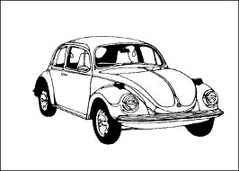





Lesson 2 - Copy and learn ( 6 – 10)





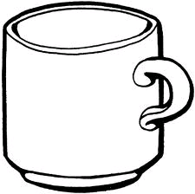



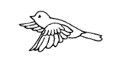



**WEEK 2**

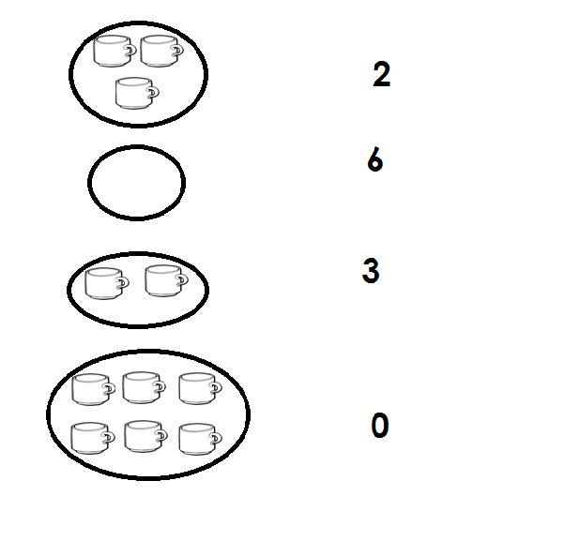Lesson 3 - Count and match

Lesson 4 - Write correctly

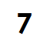



Lesson 5 - Listen and write ( 0 – 10)

**7 , 2 , 4 , 0 , 9 , 1 , 6 etc**

**WEEK 3**

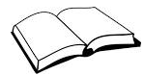Lesson 1 - Count and write ( 0 – 10)



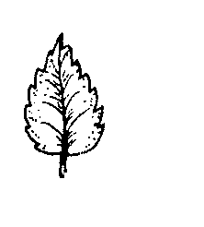



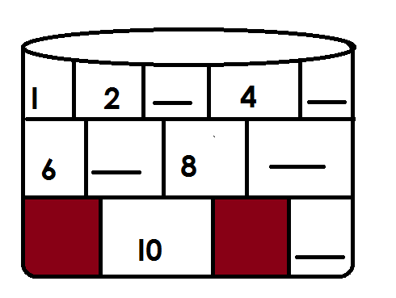Lesson 2 - Fill in the missing numbers

**WEEK 3**

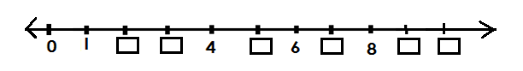Lesson 3 Fill in the missing numbers.

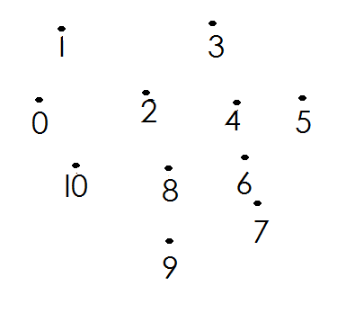Lesson 4 Join the dots ( order the numbers)

Lesson 5 Write the next number ( 0 – 5)

0 ___ 3 ___ 2 ___ 4 ___ I ___

**WEEK 4**

Lesson 1 Write the next number ( 6 – 10)

7 9 6 8

Lesson 2 Count and circle the correct number ( 0 – 10)

 3 6 5 2 I 0

6 9 I0

**WEEK 4**

Lesson 3 Draw for the given number ( 0 -10)

 2 5 7 0

Lesson 4 Shade for the given number ( 0 – 10)





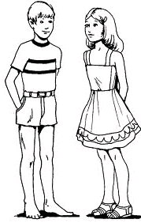Lesson 5 Complete correctly

4 = 5 =

2 = 8 =

**Week 5 SETS**

Lesson 1 Form small sets

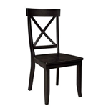







Lesson 2 Name the sets

A set of balls cups



books

 A set of trees

chairs

 A set of tins

**WEEK 5**

Lesson 3/4 Draw the set

A set of eggs

A set of tins

A set of pencil

**Lesson 5** Form count and write for the set

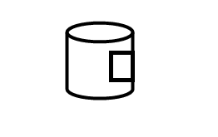 1. A set of 5 sweets



 2.

3.

**WEEK 6** Draw for the set

Lesson 1

A set of 5 bags

A set of 2 eggs

A set of 0 houses

Lesson 2 Addition of sets and pictures( 0 – 5)















**Lesson 3**  Addition sets ( 6 – 10)



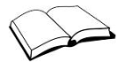













**WEEK 6**

Lesson 4 Count and write the sets ( 0 – 5)



2 I 3

















Lesson 5 Count , add and write for sets ( 6 – 10)

**e e e e e**

**e e e e**







**b b b b**

** b b b**







**WEEK 7**

Lesson 1 Addition of numbers ( 0 + 05)

2 + 0 = 3 + 2 = 2 + 1 =

Lesson 2 Add ( 6 – 10)

5 + 3 = 6 + 2 = 3 + 3 =

Lesson 3 Add ( 0 – 5)

4 3 I

+ I + 0 + I

Lesson 4 Add ( 6 – 10)

5 4 6

+ 2 + 3 + 2

**WEEK 7**

Lesson 5 Shapes

oval oval ova l

circle circle circle

triangle triangle triangle

**WEEK 8**

Lesson 1 Copy and learn

square square square

rectangle rectangle rectangle

star star star

Lesson 2 Copy and learn

zigzag zigzag zigzag

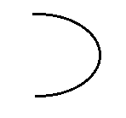 line line line

curve curve curve

Lesson 3 Read and match (shapes)

line

square

circle

triangle

**WEEK 8** Shapes

Lesson 4 Read and draw the shapes

Circle zigzag oval

**Lesson 5**

Name the shapes

(rectangle , star , curve , line)

**WEEK 9** Number names ( 0 -5)

Lesson 1 Copy and learn

Zero Zero Zero - 0

I - one one one

2 - two two two

5 - five five five

Lesson 2 **Match correctly ( 0 – 5)**

five 4

one 2

zero 3

four 1

three 5



two 0

**WEEK 9**

Lesson 3 Number names

**Copy and learn**

6 six six six

7 seven seven seven

10 ten ten ten

Lesson 4

**Read and write in figure ( 0 - l0)**

seven nine six

Lesson 5

Read and draw ( 0 -10)

two four nine zero

**WEEK 10**

Lesson 1 Fill in the missing letters ( 0 – 5)

2 tw 5 f v 0 ze

3 thr 4 our

Lesson 2 Fill in the missing letters ( 6 – 10)

9 n n 6 s 8 igh l0 en

Lesson 3 Number 11 – 20

Copy and learn

I I I I I2 I3 I3 20 20

____ ____ ___ ___ ___ ___ ___

**WEEK l0**

Lesson 4 Match and write

I2 I7

I3 20

I7 I2

20 I4

**WEEK I0**

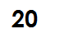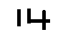Lesson 5 Write correctly

**WEEK I I**

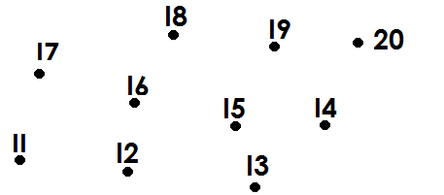Lesson I **Join the dots**